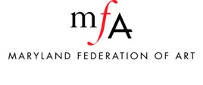
Smoking Policy
(applicable to Staff, Board, and Volunteers)

To protect the health and safety of all employees, smoking is prohibited within the confines of any MFA facility or other space used for MFA business.

