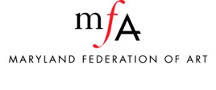
Weapons Policy
(applicable to Staff, Board, and Volunteers)

MFA prohibits employees and volunteers, whether licensed to carry concealed weapons or not, from carrying weapons on the premises of the MFA or off-site exhibition locations . This prohibition is extended to employees who have licenses to carry concealed weapons from keeping such weapons in personally owned vehicles parked on the employer’s premises.

