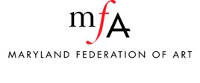
Grievance Procedure Policy
MFA is committed to addressing problems when they occur. If the staff is unable to satisfactorily resolve a complaint received from artists, the visiting public, other art organizations, funders, or other MFA stakeholders, staff members shall bring the problem to the attention of the Executive Director. MFA stakeholders are encouraged to bring any unresolved problems or concerns to the attention the Executive Director or the Board President at the earliest possible time.

